Forest Ridge PTA Newsletter | June 2020
Dear Forest Ridge Families,  As we wrap up our 2019-2020 school year, we want to say thank you for all of your support & participation in our events throughout the year. We hope you enjoyed what we planned. Our PTA wouldn’t be able to do what we do without you. With your help through memberships, attending our dine outs, Family Fun Night, Craft & Vendor Fair, Domino’s Slice the Price, Scholastic Book Fair, & Smencils, we were able to do the following things: $1,500 in Teacher Grants, $6,000 for Intramurals & clubs, $950 towards books to the school libraries, BOO-ingo & Trunk-or-Treat, & Sock Hop. Our team is looking to fill some of our board positions due to people moving up to the next school level. There are 2 V.P.’s at Ridge, 2 V.P.’s at Kerkstra, & an Art Chairperson available. If you want to help make an impact on our schools, our community, & especially our children please contact Tracy Zerinskas at d142ptapresident@gmail.com or send us a message on Facebook Messenger.  We will have one last dine out to kick off the summer. On our last day of school, June 9th, we will be heading over to Oberweis for so yummy ice cream. You can come anytime from 10am-10pm and you need to bring in the flyer. There’s one at the bottom of the newsletter or you can print one from our website. Hope you can come out one last time to support us.  We will be doing School Supply Kits again this year. More information will be emailed over the summer with additional details. We will also post this info on Facebook, Twitter, & our webpage when it’s available.  Next, we want to thank our teachers, staff, and administration for everything that you did for our students throughout the year. We weren’t expecting the year to end the way it did but you stepped up to the challenge with a lot of unknowns. Thank you and we appreciate all of your support especially coming to our events. It meant the world to us.  Finally, I especially want to thank my PTA team!!! Their names & positions are on the right side of the page. James Dolittle once said “There’s nothing stronger than the heart of a volunteer.” This is especially true for them! Without you we wouldn’t have a PTA. You put in long hours on top of your regular day to things like work, your child’s schedules, other places you volunteer, & just life itself. Your hard work has not gone unnoticed. You go ABOVE & BEYOND for our schools & kids. I can’t thank you enough for how amazing you all are. Each one of you has a special talent & uniqueness that you bring to PTA. With your skills and passion, we’ve been able to exceed our vison this year. Thank you for making my first year as president a memorable on.  Thank you again for a great year!  Tracy Zerinskas & Your Forest Ridge PTA team | Upcoming Events  June 9th-Oberweis Dine Out 10am-10pm***Must  Bring Flyer***  Last Day of School June 9th!! Enjoy your summer  *School Supply Kit order forms will be emailed over  the summer.  *Stay up to date on what’s going on by following our  social media.  Follow us on:  Website: frpta142.com  Facebook:  Forest Ridge PTA  Ridge PTA  Kerkstra PTA  Foster PTA  Hille PTA  Twitter:  @d142PTA  @Foster_PTA  Special Thank You to my 2019-2020 PTA Board:  Executive Board  Dawn Omiecinski-Vice President  Regina Tarchala-Secretary  Amanda Guerrero & Tracey Breitbarth-Co-Treasurers  V.P.’s & Chairpersons  Nichole Lies & Richita Jones-Co-V.P.’s @ Ridge  Claire Gazdziak-V.P.’s @ Kerkstra  Lisa Vanderwall-Kerkstra Mentor  Martina Bemis & Adam Wimunc-Co-V.P.’s @ Foster  Diane Wronowski & Darcy Alaska-Co-V.P.’s @ Hille  Sandy Baytala-Teacher Representative  Arlene Olson-Program Chairperson  Megan Maney-Art Chairperson  Joel Wrzesinski-Marketing Chairperson
Don’t forget to download the BOX TOP app. Scanning your receipt is easy & only takes a couple of minutes. Keep clipping & sending box tops in too. This goes directly to your school & the programs they have there. Easy money for our schools.
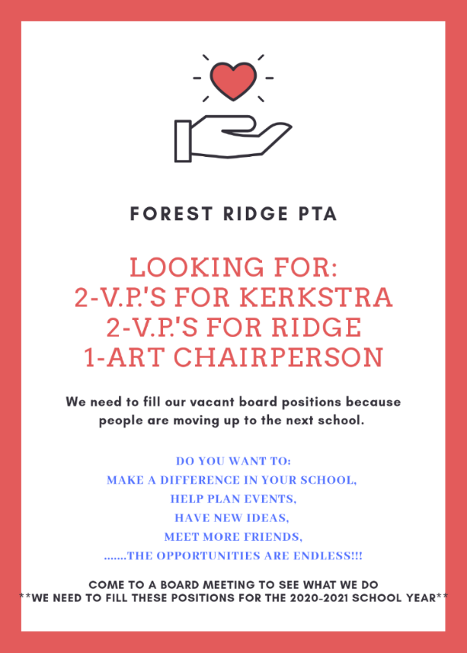

CHECK OUT OUR VIDEOS ON YOUTUBE

Forest Ridge D142 Teacher & Staff Appreciation Week 2020
https://youtu.be/MSodpD0XSUk

Forest Ridge D142 End of Year Thank You 2020
https://youtu.be/HfbepebSEA0
